# Setting up a test patient for the NHS App

Once your surgery has been connected you can set up a test/dummy patient. This is a useful way to see how patients view your practice when they use the NHS App. You will not be able to set up a test/dummy patient until after your GP surgery has been connected to the NHS App

During the NHS App pilot the NHS App encouraged many people to use their GP surgeries digital services for the first time. Many surgeries did not realise how their system was configured and there were often not enough appointments available online or appointments were named in a way that was confusing for patients.

## How to set up test patient access to the NHS App

You will need:

1. A test/dummy patient that is:
   1. Active on the system
   2. 16 years of age or older
   3. Assigned a test/dummy NHS number
2. An email address to link to the test patient. You could use your practice email or create a new email on Gmail/Outlook.com/Yahoo! Mail etc.
3. A mobile number you can link to the test patient.

|  |
| --- |
| For support on creating a test/dummy patient contact your system supplier or local ICT team |

### Step 1: Register the test patient for online services

Register your test/dummy patient for online services on your practice system and print out a registration letter that has:

* Linkage Key (could be called a Passphrase)
* O.D.S. Code (could be called an Organisation Code or Practice I.D.)
* Account I.D.

You should also record the test/dummy patient’s:

* First Name
* Surname
* Date of Birth

### Step 2: Download the NHS App

Visit [www.nhs.uk/NHSApp](http://www.nhs.uk/NHSApp) and download the NHS App onto an Apple or Android device

Download the NHS app on the App store (Apple)Download the NHS app on Google Play (Android)

### Step 3: Find your GP surgery

Open the NHS App and Find your GP surgery. If your surgery is connected you will then be prompted to create an NHS Login account.

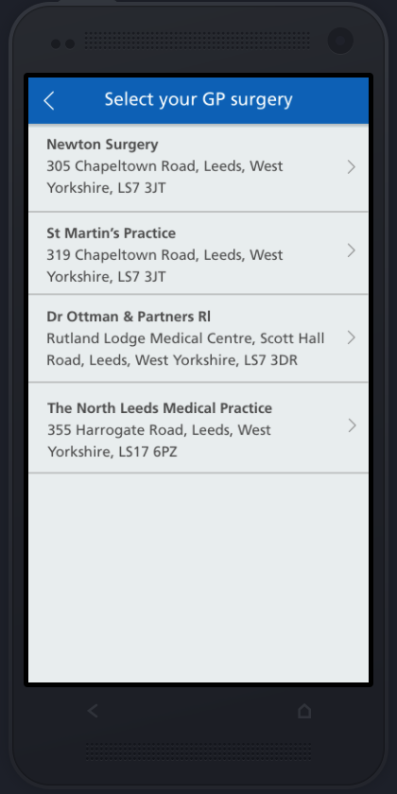 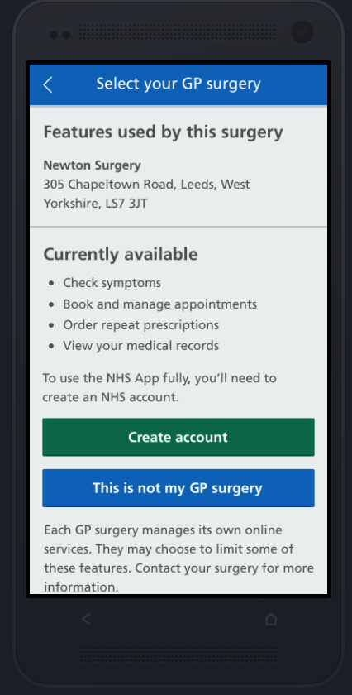 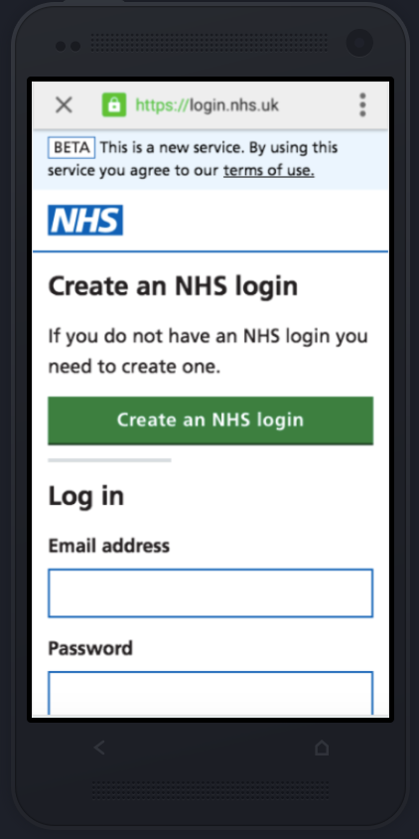

### Step 4: Creating an NHS Login

Follow the instructions to create an NHS Login for your test patient using the email address and mobile number you intend to link to the test patient to create the account. When asked “Do you have all 3 registration details” select “Yes” so you can link the new NHS Login account to the test/dummy patient on your system.

Remember to use the test/dummy patient’s First Name, Surname and Date of Birth when prompted.

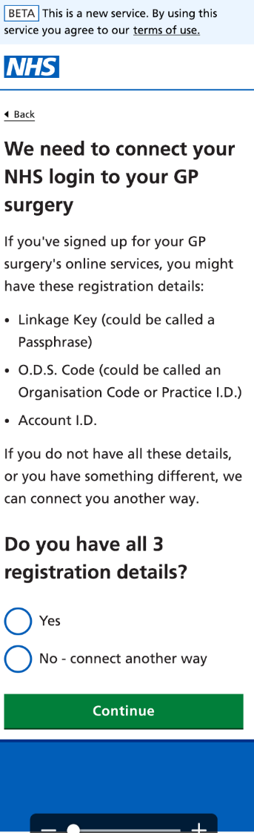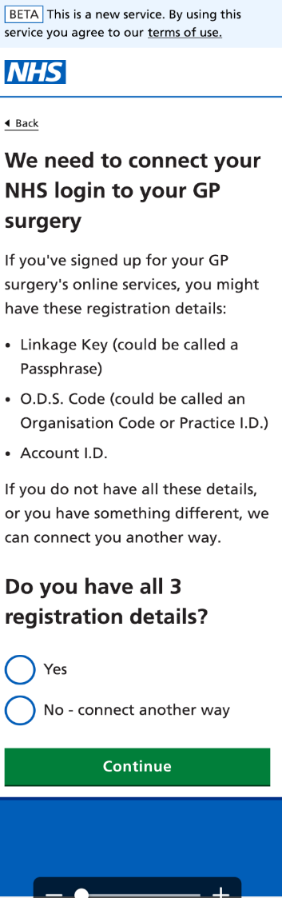

### Step 5: Login to the NHS App

Login to the NHS App using the NHS Login account you have created. If you need to change the email address or mobile number linked to this NHS Login account you should contact technical support at <https://www.nhs.uk/contact-us/nhs-app-contact-us>